Unit 4 - A Long Journey to Freedom
Hero or Heroine | Life Span | Character Traits | What did he or she do for freedom? | Famous Quote
Harriet Tubman
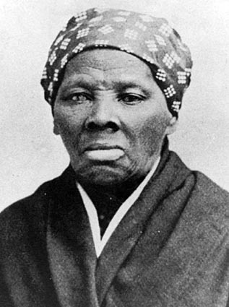

Henry Brown
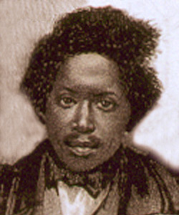

President Lincoln
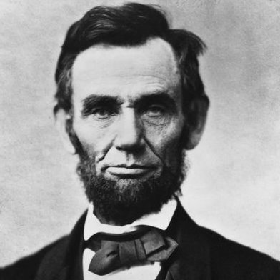

Langston Hughes
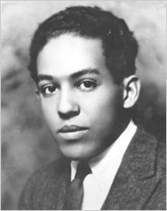

Hero or Heroine | Life Span | Character Traits | What did he or she do for freedom? | Famous Quote
Jesse Owen
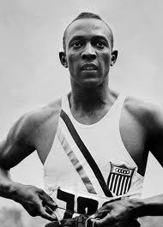

Rosa Park
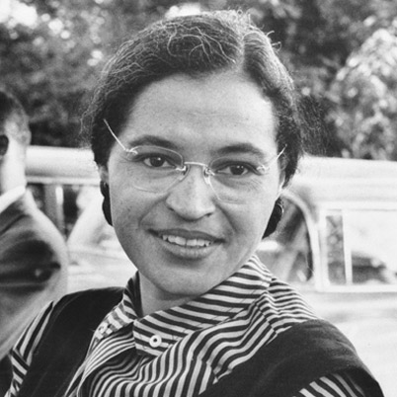

Ruby Bridges
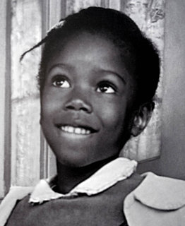

Martin Luther King Jr.
